Across globally, visionary infrastructure and utilities development is transforming nations, powering economic diversification, and shaping world-class urban experiences. Rapid urbanization, technological advancements and demographic shifts are just a few factors contributing to the world’s increasing demand for modern and powerful infrastructure — with this comes the daunting task of recruiting a talented workforce for your global infrastructure projects
From conceptual design to final completion, LEADPEC infrastructure experts for monumental projects worldwide. We pair talent with main contractors, design houses and traditional PCM and EPC projects to build roads, bridges, highways, dams, tunnels and more

Infrastructure: The Challenge
- Project demand: Rapid urbanization and technological advancements are driving up demand for new and resilient infrastructure
- Global demand for skilled talent: Infrastructure projects are becoming larger and more complex than ever before, driving up global demand for top expertise
- Need for quick workforce access: Rapid industry growth makes it hard to find enough skilled workers in short time frames
- Finding local talent for global projects: It can be difficult to find the regional workforce you need for local projects
- Maintaining a safe work environment: Having a strong and unified safety compliance strategy is difficult to achieve worldwide

The Brunel Solution

✔ Local connections: With local relationships, in-country expertise and established offices, we quickly find the local workforce you need

✔ High-volume hiring: Fast access to top talent in large numbers

✔ Safety and compliance prioritized: With emergency help available 24/7, our HSEQ safety compliance standards give peace of mind

✔ Global mobility & visa capabilities: Proven track record of recruiting and placing experts in often challenging nationalities, backed by reputable local partners

✔ Remote site services: Unparalleled food, furnished staff accommodation and site transportation services even in the most remote locations— including building full campsites at worksites

Infrastructure & Utilities
A Region Investing in Tomorrow
From next-generation smart cities to integrated transportation networks and infrastructure to deliver landmark projects that set new global benchmarks. Governments across the region are prioritizing:
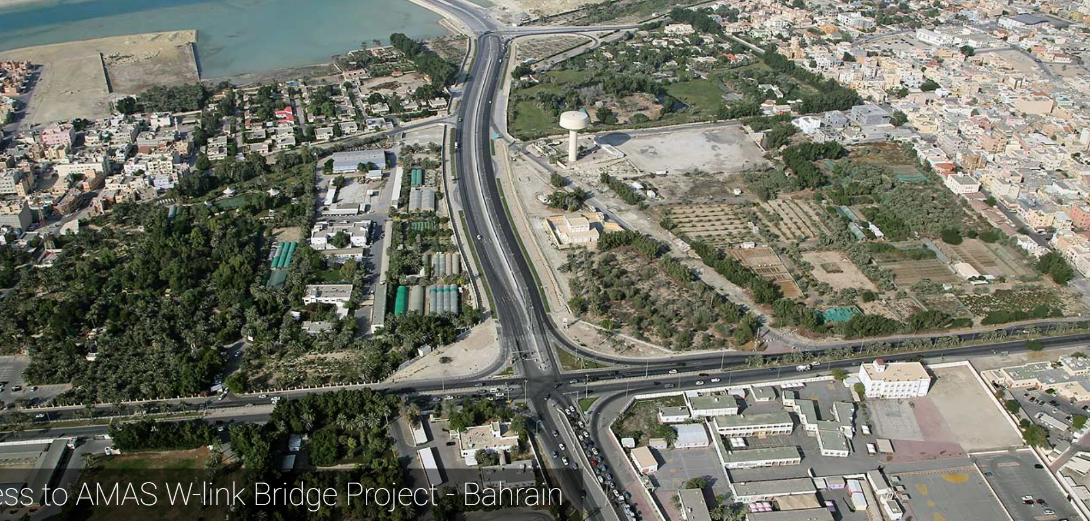

Bridge Construction Technology in the GCC
• LEADPEC connects the people who build the crossings that move the world.”
• “Stronger bridges start with stronger talent. LEADPEC delivers both.”
Modern bridge construction blends trusted engineering with fast advancing technology. Around the world, project teams push for structures that deliver durability, speed, cost efficiency, and environmental performance. The industry relies on a core set of technologies that offer strong results across varied terrain and project demands.
Precast and Segmental Construction
Used for rapid, precise assembly on major interchanges, metro corridors, and high volume highways. Factory controlled production cuts time on site and raises overall quality.
Post Tensioning and Prestressing Systems
Essential for long spans and heavy traffic routes. These systems support elevated expressways, large viaducts, and any project where strength and service life matter.
Incremental Launching and Balanced Cantilever Methods
Ideal for locations with restricted access or live traffic. These approaches enable controlled, staged construction with high accuracy across extended spans.
Steel and Composite Bridge Systems
Chosen for lighter weight, fast erection, and design flexibility. They perform especially well in coastal and industrial zones where efficiency and resilience are key.
Cable Stayed and Suspension Technologies
Used for signature crossings and major waterways. These systems deliver iconic, long reaching spans that combine engineering performance with visual impact.
Arch and Truss Solutions
Reliable options for rail, highway, and difficult terrain. Their strong load distribution and structural efficiency make them proven choices in both steel and concrete.
Digital and Automated Technologies
BIM, robotic surveying, automated precast production, and digital quality control now drive global bridge delivery. These tools sharpen accuracy, improve safety, and reduce rework.
Across all regions, these technologies depend on skilled engineers, supervisors, project managers, technicians, and tradespeople who can deliver precision work under complex site conditions. As nations expand transport networks and invest in climate resilient infrastructure, demand for specialized bridge construction talent continues to rise worldwide.

Road & Utilities Construction Technology
"Engineering the Future of Infrastructure, Powered by People and Precision"
Road and utilities projects form the backbone of modern cities and national economies. Around the world, governments and private enterprises rely on advanced construction technologies to deliver safer highways, smarter utility networks, and durable underground systems. Successful projects depend on the seamless integration of precise engineering, modern equipment, and highly skilled teams capable of executing complex work under pressure.

Road Construction Technology
Pavement Engineering & Asphalt Innovation
High-performance asphalt mixes, warm-mix technologies, and modified binders deliver enhanced durability, lower maintenance, and long-term strength. These innovations are essential for heavy traffic corridors, freight routes, and high-speed expressways.
Concrete Pavements & Rigid Systems
Where strength and longevity are priorities, slipform paving, dowel bar insertion, and laser-guided grade control provide precision, consistency, and lasting performance.
Automated Grading & Earthwork Technology
GPS-controlled graders, LiDAR-enabled surveying, and 3D machine control improve accuracy, reduce rework, and accelerate bulk earthworks, becoming standard practice on major highways and urban expansion projects.
Drainage & Stormwater Systems
Engineered channels, culverts, and deep stormwater networks protect roads from flooding and erosion. Precision installation and proper compaction are critical for long-term resilience and safety.
"From Foundation to Finish – Technology Meets Expertise on Every Road."

Utilities Construction Technology
Water & Sewer Network Installation
Modern trenching systems, pipe bursting technologies, and advanced jointing methods ensure reliable, durable underground networks. Materials like high-strength PVC, HDPE, GRP, and ductile iron optimize performance and simplify maintenance.
Electrical & Telecom Infrastructure
Duct banks, micro-trenching, and fiber deployment technologies support efficient power distribution and high-speed communication networks. Precision alignment and controlled compaction minimize service disruption and maximize reliability.
District Cooling, Gas, & Industrial Utilities
Specialized installation of large-diameter pipelines, insulated networks, and corrosion-resistant coatings underpins smart city infrastructure and industrial systems, demanding both technical expertise and exacting standards.
Utility Mapping & Detection Technologies
GIS mapping, ground-penetrating radar, and digital inspection tools reduce clashes, enhance safety, and improve long-term maintenance planning.
"Building Smarter Cities, One Utility at a Time."

Why Choose Market-Driven Expertise?
Successful infrastructure projects require more than technology—they require people who know how to use it. Our recruitment and consulting services connect industry-leading talent with the latest construction technologies, ensuring projects are delivered on time, on budget, and to the highest standards.
"Precision, Performance, People – That’s How We Build the Future."

